**Project Design Phase**

**Problem – Solution Fit Template**

|  |  |
| --- | --- |
| Date | 28 June 2025 |
| Team ID | LTVIP2025TMID49827 |
| Project Name | Heritage Treasures: An In-Depth Analysis of UNESCO World Heritage Sites in Tableau |
| Maximum Marks | 2 Marks |

**Problem – Solution Fit Template:**

Despite the global recognition of UNESCO World Heritage Sites, there is a lack of accessible, visually engaging platforms for analyzing and understanding their distribution, types, regional statistics, and current threats such as endangerment or degradation. Raw datasets can be overwhelming and uninformative to the average user or policy-maker.

This project leverages Tableau to transform complex UNESCO heritage site data into interactive, visually compelling dashboards. It provides clear insights into trends, categories, regional distributions, danger zones, and area analytics, making the information easy to explore and understand for educators, students, travellers, and heritage conservationists.

**Purpose:**

* To create interactive Tableau visuals of UNESCO World Heritage Site data.
* To raise awareness about cultural and natural heritage.
* To support heritage protection through data insights.

**Template:**

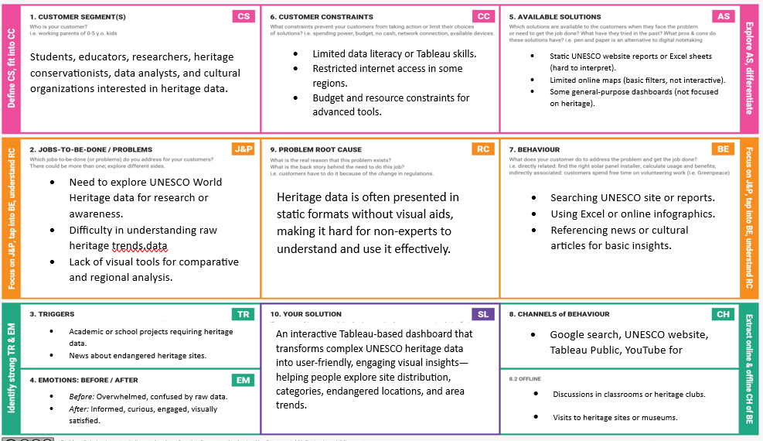

References:

1. <https://www.ideahackers.network/problem-solution-fit-canvas/>
2. <https://medium.com/@epicantus/problem-solution-fit-canvas-aa3dd59cb4fe>